A bar plot that showing the percentage of positive, negative and neutral tweets

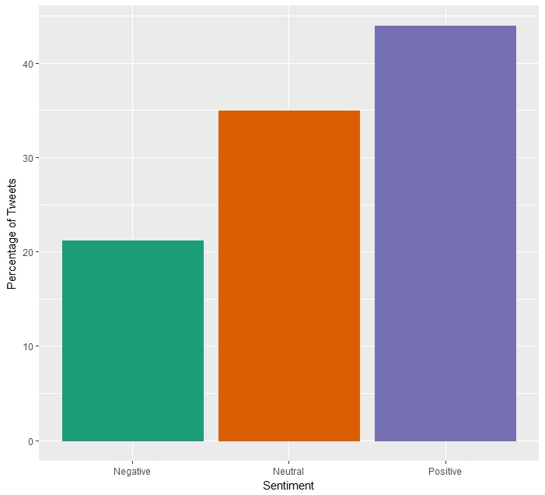

A map of where some of the tweets originate from, the blue dots indicate the origin of the tweets

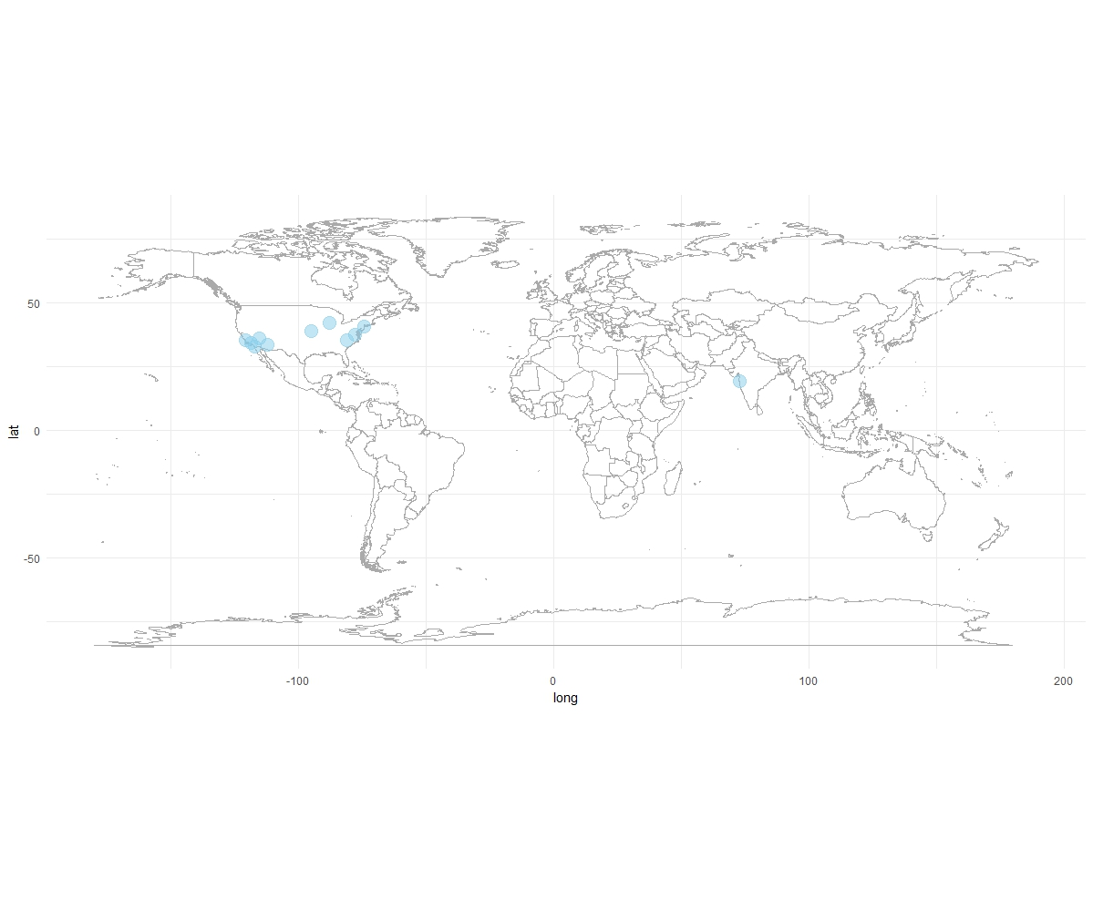

The top 5 positive words and negative words, put in a graph that shows the percentage that of how they showed up in tweets

